Dear
I hope you are enjoying the summer despite the ongoing temperatures.
WEBSITE
As you are aware, our site was hacked along with other WordPress websites. A few people have voiced concerns about the impact on our Beacon System. They are independent of each other. The website is for information and does not contain any personal details of members.
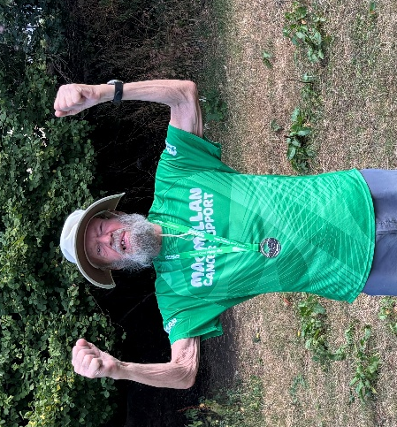
Over the summer we have been updating the website and have just about finished the new version which we were going to launch at the start of the new season. The situation has brought forward the launch and we hope to have it up and running by the end of next week.
MIKE’S MIGHTY HIKE
Mike Andrews has completed the half Marathon Mighty Hike and raised, with members help, £1,786.64p, for Macmillan Cancer Support. A big thank you to all those who donated.
Mike with his medal

NEW GROUP LEADER MEETING 7th SEPTEMBER
For those new to group leadership, we are hosting a get-together at Parley Place Care Home on Monday 7th September at 2.00 pm. This is an opportunity for new group leaders to meet other group leaders and ask any questions they may have. If you would like to attend, please contact Paul Ellis, our group leader coordinator. Groupcoord@ferndownu3a.co.uk

DORSET ARCHITECTURAL HERITAGE WEEK - 11TH – 20TH SEPTEMBER
If you don’t already know about the Dorset Architectural Heritage Week (September 11th- 20th), you might be interested in finding out what it includes. It’s part of the national Heritage Open Days programme and includes nearly 70 historic properties in and around Dorset. During that week, entry to all the activities is free (including some that normally charge for admission). You can get more details from the East Dorset Heritage Trust (info@edht.org.uk) or pick up a coloured brochure at Allendale House in Wimborne.

WINDOR CASTLE AND TOWN VISIT – 25TH SEPTEMBER 2026
We are planning a visit to the Castle and town.
Look out for further details next week. To new members we would emphasise that our visits do get booked up quickly, so a prompt response helps.

VOLUNTEERS
Have you some time to spare?
This year we will see the retirement of some committee members, and we are looking forward to welcoming some new people to carry on the wonderful work the Ferndown U3A committee undertakes. Please come forward and join us. We cannot grow without active committee members and new ideas. Many hands make light work!

In addition, Keith Banks is no longer able to help set up the Audio-Visual equipment. Keith is happy to explain what needs to be done. It is monthly job at the Barrington First Fridays. September – May.

AUTUMN TERM START DATE 14TH SEPTEMBER
Fu3a starts back on 14th September with a welcome-back meeting, open to all, on Friday 18th September.
Tea / Coffee and Biscuits from 9. 45 am in the Barrington Theatre.

Best wishes
Anne and your Committee

